

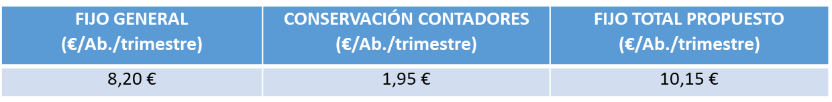





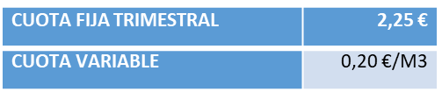



|  |  |  |
| --- | --- | --- |
| **M3 CONSUMIDOS AL TRIMESTRE** | **PRECIO (EUROS) TRIMESTRE** | **PRECIO (EUROS) MES** |
| **0** | **13,85** | **4,62** |
| **10** | **19,90** | **6,63** |
| **20** | **27,88** | **9,29** |
| **30** | **37,78** | **12,59** |
| **40** | **51,53** | **17,18** |
| **50** | **65,28** | **21,76** |
| **60** | **79,03** | **26,34** |
| **90** | **154,93** | **51,64** |
| **150** | **306,73** | **102,24** |
| **300** | **686,23** | **228,74** |
|  |  |  |
| **30** | **Consumo normal 1 familia** | |